3.3:

TOP keyword:

Used to display a selected percentage or no. of values

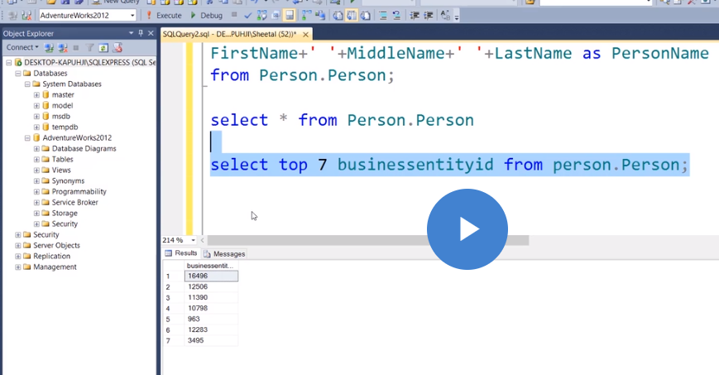

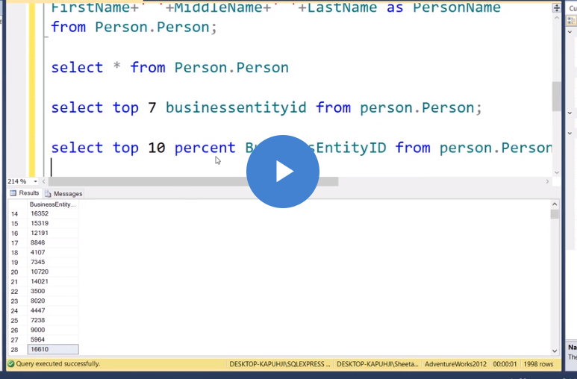

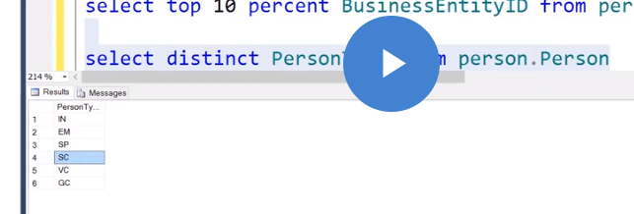

AS keyword:

The column headings can be renamed by using ‘AS’ keyword. This concept is known as column aliases.

Distinct keyword:

Used to prevent the retrieval of duplicate values in a column.

Where clause:

Used to limit the records being returned. (use conditional operators like =,<,>)(put strings in single quotes)

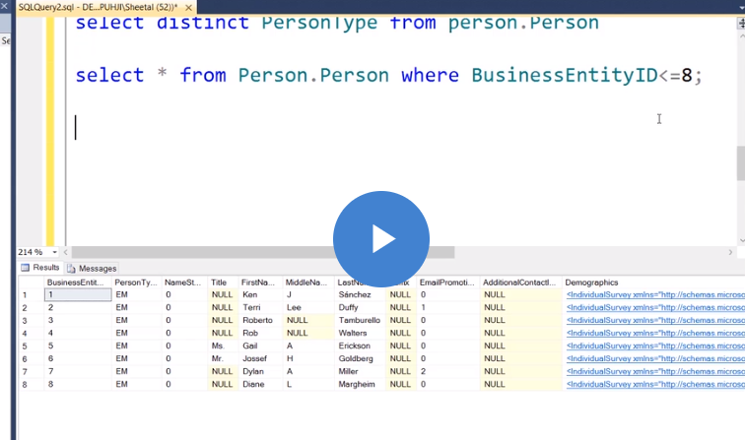



Is null

In case of null values, do not write =null

Use operator “is null”

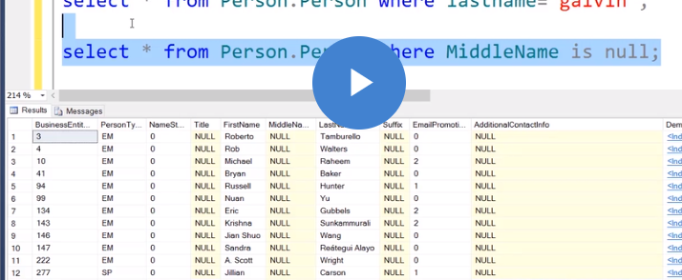

Similarly, “is not null” operator can be used.

Like operator:

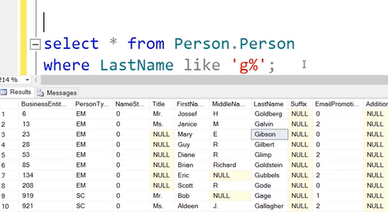

There can be 0 or more than 0 characters after g. Used to match a part of a particular column.

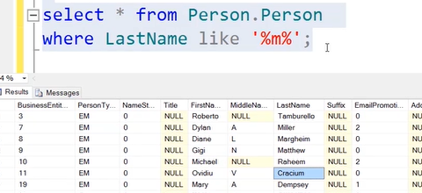

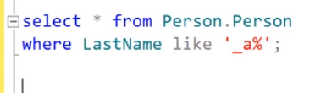

Select the records where the second letter is a.

Similarly, “not like” can be used.

Between operator:

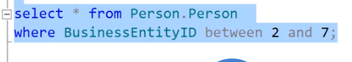

*2 and 7 are both included. [2,7]

IN operator:

Similar to = operator, just with the difference that we can use multiple values. Uses dates, numeric and char.

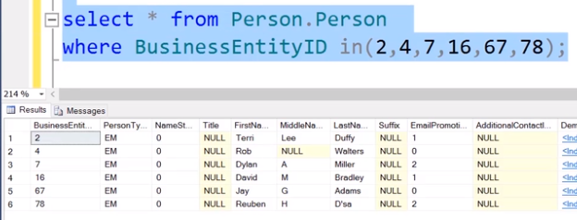

Similarly, NOT IN operator.

AND, OR operators are also used.

Order By clause:

Used to order the result set of a query by the specified column list and optionally, limit the rows returned to a range. (sorting basically)

ASC Ascending(Default) DSC Descending

NULL is treated as lowest value.

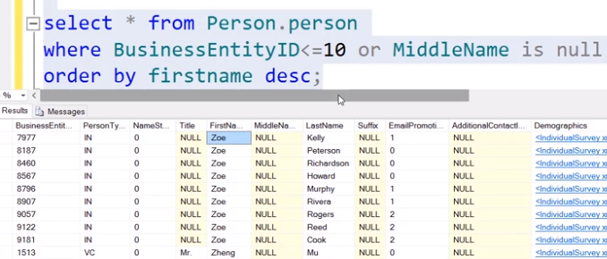

Aliases can also be used.

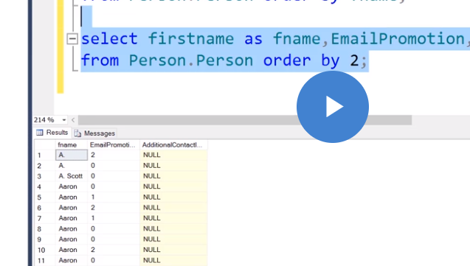

This means sort on the basis of the column no.(eg.2)

You can also use more than 1 column in order by clause.



In above case, priority will be given to title. Persons having the same title will be ordered on the basis of firstname.

System functions:

len(): to find the size of length

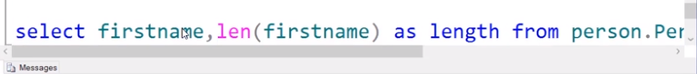

Left(): to display the first n nos. from the left hand side.

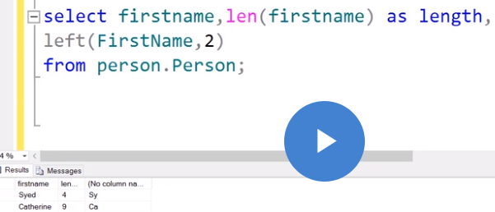

Right(): similar as left

*do not use keywords anywhere for variable names of values

Substring():

Syntax: substring(col_name, start_position, no._of_letters)

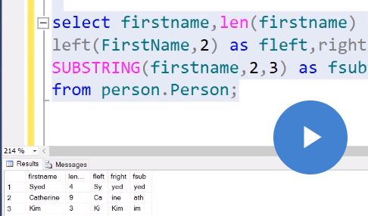

Concat(): To join 2 or more strings(concatenation)

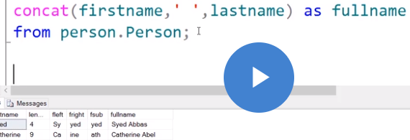

3.4:

String functions: those which perform operations on strings.

Replace(): Syntax:replace(col_name, original, new)

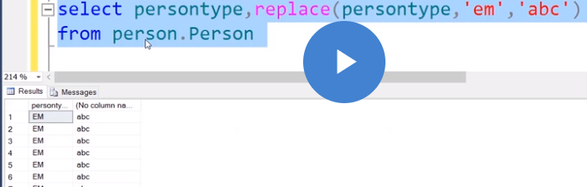

Upper(): To convert to upper case. Similarly, there is lower()

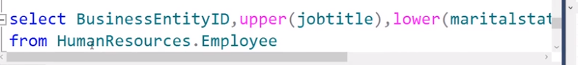

Date and Time functions:

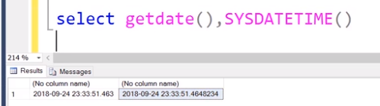

Getdate(), sysdatetime(): Both show current date and time but differ in the format.

Datefromparts(), datetimefromparts():

Enter a particular date: datefromparts().Format: yyyy/mm/dd

Enter a particular date and time: datetimefromparts().Format: yyyy/mm/dd/hr/min/sec/msec

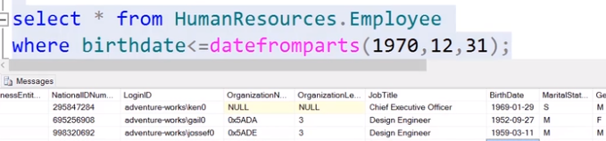

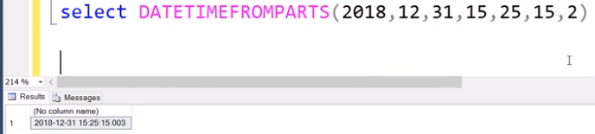

Dateadd(): syntax:dateadd(interval, incr_int, expression smalldatetime)

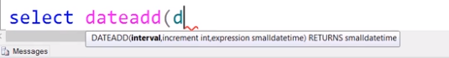

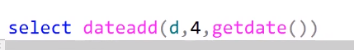

This adds 4 days to current date.

Month(), year() and day(): To extract the month, year and date.

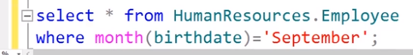

Similarly with months and years.

*Note: to display date, we use keyword day

Datediff(): To find date difference in days, months or years.

Datediff(interval, start_date, end_date)

Can write d or day, m or month, y or year

Mathematical functions:

Rounding off :

Ceiling(): upward value eg. 5.9 ->6

Floor(): downward value eg. 5.9->5

Power():>power(2,3) gives 2^3

Sqrt() and square()

Abs(): absolute value

Group functions: operates on set of rows to give one value

Sum()

Count()

Avg()

Min()

Max()

Sum() and avg() work only with nos.

These can also be used along with WHERE clause.

GroupBy clause:

Divide the query result into groups of rows, usually for performing one or more aggregate functions.(groups multiple entries with some common entity).

*Attribute used in groupby should also be in the select clause. The select clause can include only the statement in the groupby clause or a column using an aggregate function.

Having clause:

Used in conjunction with groupby to retrieve the values of functions only for groups that satisfy certain conditions. (first creates groups and then filters in case of for clause which filters and then creates groups )

*We cannot write a group function in where clause, it can only be written in having clause. (main difference)

It specifies a search condition for a group or an aggregate.

*A Scheme is basically a group of tables.

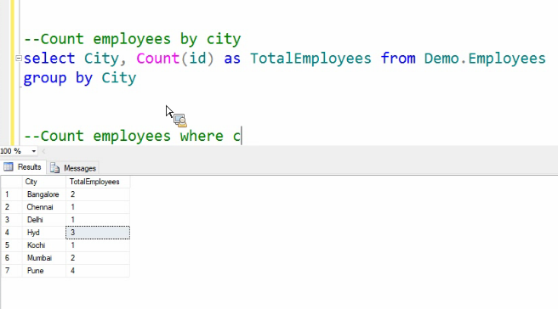

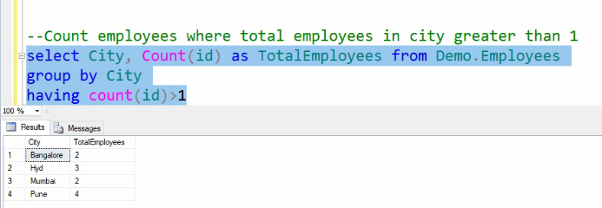

We can’t use where clause along with an aggregate function. That is why having is preferred.

Grouping sets:

The grouping sets option allows you to group multiple groupby statements into one statement.

The results are the equivalent of Union all operation.

GroupByRollUp: Creates a group for each combination of column expressions.

GroupByCube: Creates groups for all possible combinations of columns.

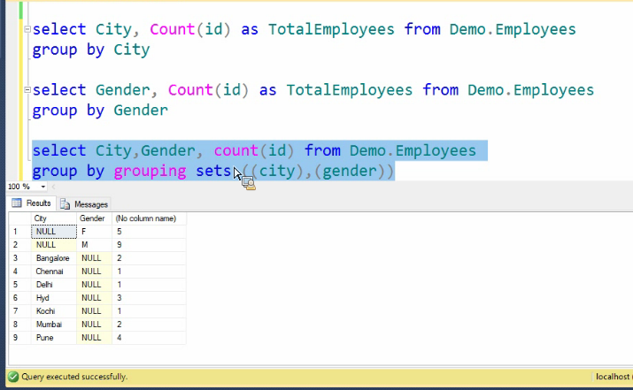

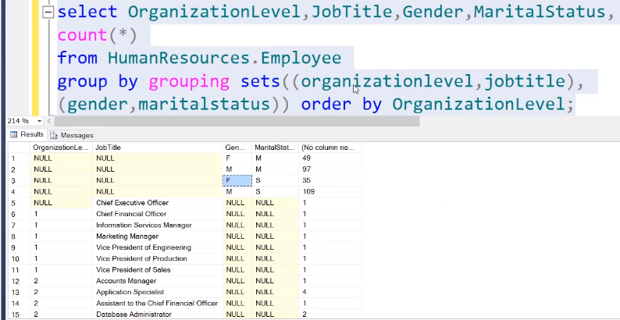

Rollup:

All possible values, sub-total and grand total also included.

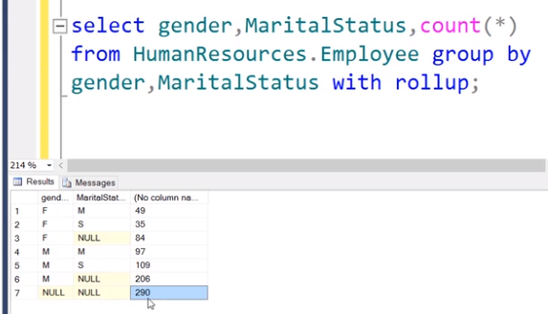

Cube:

Cube gives more no. of combinations.

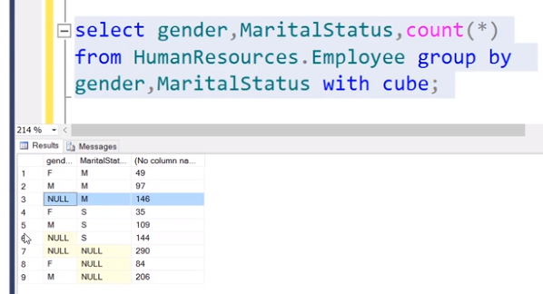

SET operators:

Used to combine data from 2 tables or the results of queries.

Union

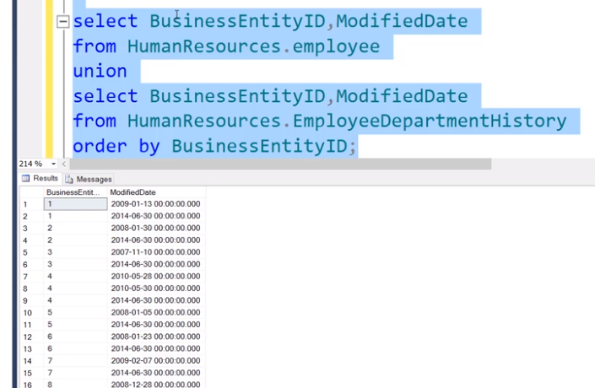

Union all gives the union of the 2 queries but it does not eliminate the duplicate records.

Intersect

Except works like difference.(A-B)

Rules:

Same no. of columns in both queries

OrderBy statement should be at the last.

Column aliases should be in first select statement.

Joins:

Used to combine rows from two or more tables, based on some common field.

Inner Join: matching records from both the tables.

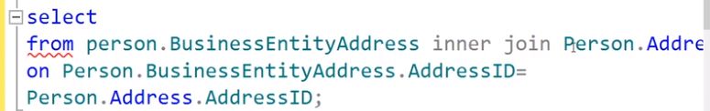

->Where clause can also be used.

->Columns containing null values do not match any values.

->Null values do not match other null values.

Outer Join: matching as well as unmatching records.

Left Outer Join: All rows from the left table along with matching values in the right table.

Right Outer Join: All rows from the right table along with matching values in the left table.

Full Outer Join: All matching and unmatching values from both tables.

Where the records do not match, it returns null.

Self Join: A join of a table to itself. Keyword used is inner join.

Cross Join: All possible combinations of rows.(Cartesian product)

Subquery: A subquery is a query that is nested inside a select, update, insert, delete command or another subquery. It can be used anywhere an expression is allowed. Also known as inner query.(enclosed in parenthesis)

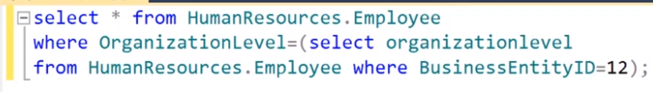

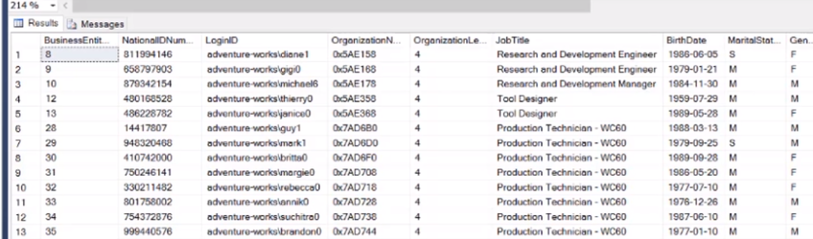

All values returned where orgLevel is 4.

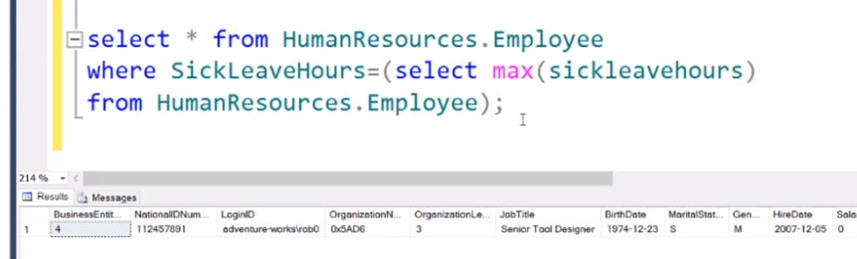

Other operators can also be used like!=,<,>

If for eg. In the above query, if the inner query returns more than 1 value (multiple row subqueries) then the outer query won’t be executed. For this purpose, we use multiple row operators.

ANY, ALL operators:

Any:

Inner query:

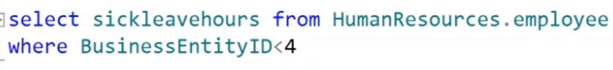

Output: 69, 20, 21

Outer query:

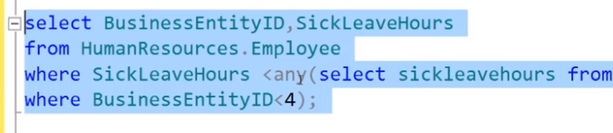

Select the entries where sickleavehours<(one of 69, 20, 21)(works like OR)

All:

Inner query: same as above

Output: 69, 20, 21

Outer Query:

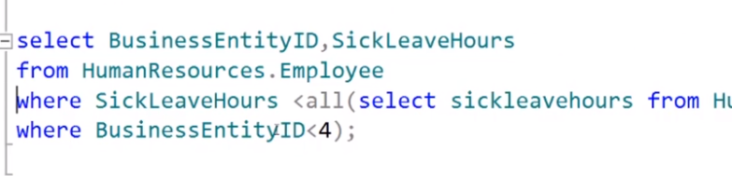

Select the entries where sickleavehours<(all of 69,20,21 works like AND)

2 types of subqueries are: multiple and single row

Single row query operators:

<, >, =,>=,<=, !=, <>

Some operator: The same function as ANY operator.(only difference is that ANY is ANSI standard but SOME is SQL standard)

Above subqueries were nested.

Now,

Correlated queries:

Subquery used when the subquery needs to be executed more than once.

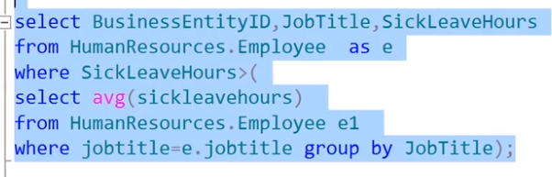

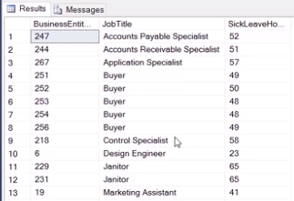

Table and variable name should be alphanumeric, but not starting with a no. and not using keywords, spaces or special characters, except _.

Identity(10, 10 ) means starting value 10 and increment 10(written after int)

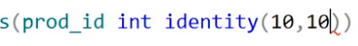

sp_help is used to retrieve stored procedures.(a predefined function to display the table structure.)

sp_help table_name

while using insert statement, if we are using the same order then no need to write the col_names but if order is changed, we need to.

Date or string operations should be put in single quotes.

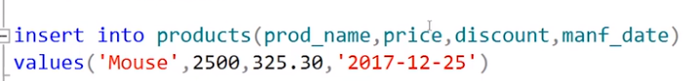

Multiple values can be added using one insert statement.

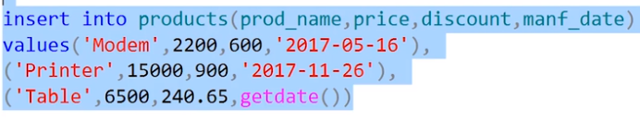

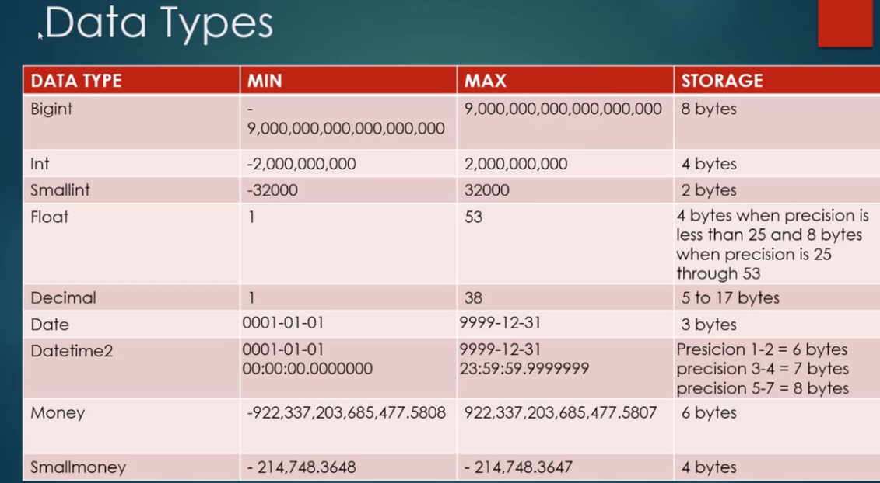

More data types:

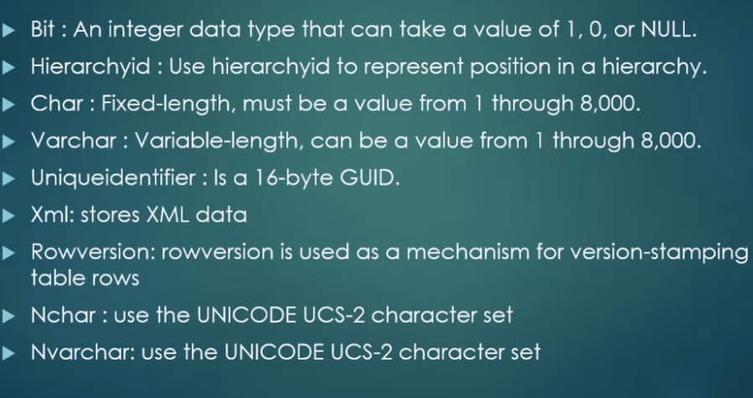

Char is fixed length and could lead to wastage of space

whereas varchar is variable length.

Nchar and nvarchar are used for Unicode character sets.

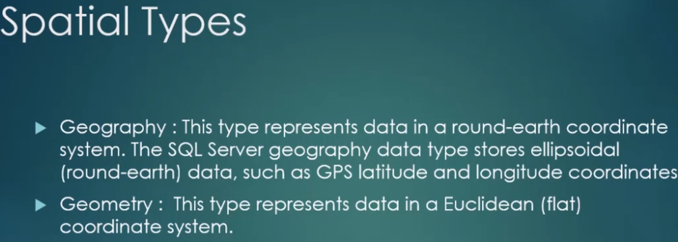

Create type statement is used to create an alias data type or a user defined data type.



Data Definition Language (DDL)

Used to define the database or table structure.

Create, alter, drop, rename, truncate.

Data Manipulation Language (DML)

Used to manage data

Insert, update, delete, select, merge

Data Control Language(DCL)

Used to give privileges to access limited data.

Grant, revoke

Transaction Control Language(TCL)

To apply the changes permanently to the database.

Commit, rollback, savepoint

Schema:

Schema is a collection of database objects associated with a particular username.Create schema keyword. By default, saved in dbo schema(database owner)

DDL commands are auto commit, whereas DML commands can be rolled back.

To display the columns in a table, the system table sys.tables can be used.

To copy values from one table to another:



Update:

update table <table_name> set column_name=value where <condition>

delete <table_name> where <condition>

enter all the data from one table to another.



(can be used to create new table without create statement)

Alter:

Add new columns:



Change data type or change size of datatype:



To drop a column:



To rename a column:

Alter table <table_name> rename <column_name> to <new_name>

Drop statement is used to remove a table from the database.

Computed column: A computed column expression can use data from another column to calculate the value.

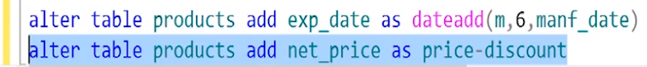

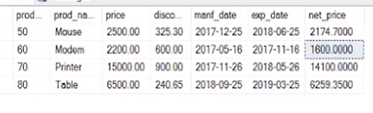

Merge: Used to modify data in a target table based on the data in a source table. It joins the target to the source by using a column common to both tables, like a primary key.

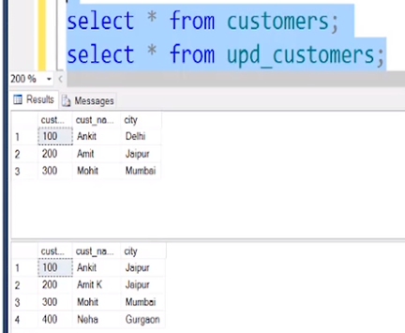

To apply the changes from table 2 to table 1, we need to alter values, add those that are absent and remove extra values. Source table is the below one.

Merge <target_table> as <source_table> on <condition>

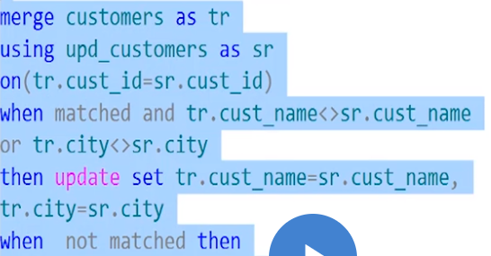

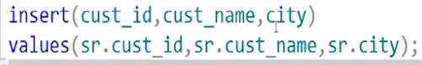

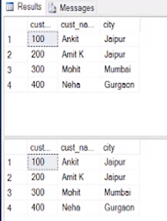Now, both the tables contain the same data values. All the changes have been made.

Constraints: Rules and regulations imposed on a column or a table. This maintains the accuracy and reliability of data in a database.

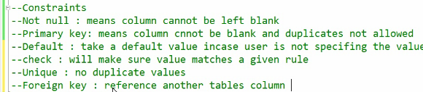

Primary Key constraint is a combination of unique and not null.

Foreign key constraint is also known as referential integrity constraint.

Constraint name can be given



Constraints can also be imposed using alter table statement.



While using update statement(any dml commands), constraints are checked.



Default:

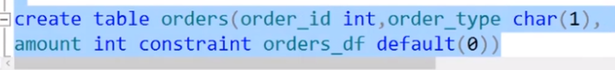

Foreign key

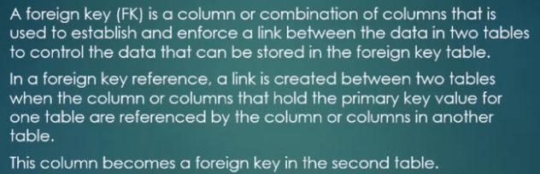

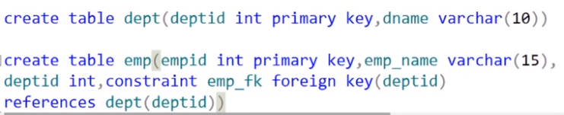

Dept table is the parent while emp table is the child table.

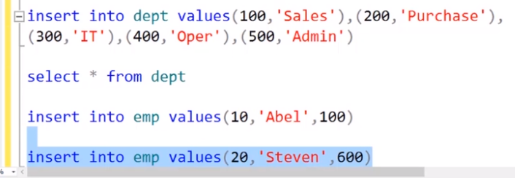

It will show an error because 600 isn’t present in the parent table.

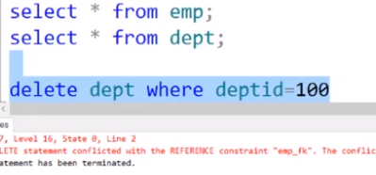

Values cannot be deleted because matching values exist in the child table.

Table or its column also can’t be dropped

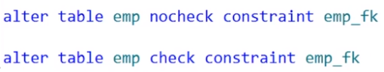

To disable and enable a constraint.

Cascade

It is basically like the domino effect

The action for cascade on delete is to delete all the referencing tuples, whereas on update, it is to change the value of the referencing foreign key attribute to the updated primary key value for all referencing tuples.

Set Null, Set Default

Any of the above 3 options must be qualified with either on delete or on update.

Eg. On delete set null and on update cascade

Hierarchyid:

The data type hierarchy id is used to represent a position in a tree hierarchy. Eg. An employee’s position in an org.

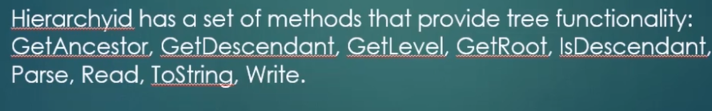

Topmost node is the root node.





Root node, level 1, CEO

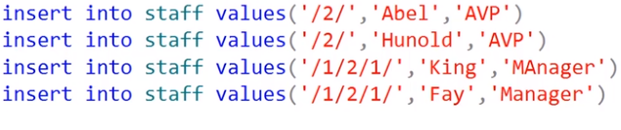

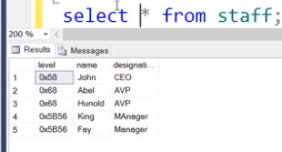

Levels in hexadecimal



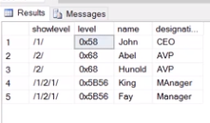Levels in numeric form

Identity data type:

Used to automatically generate values based on a seed(starting point) and increment.(decimal,int,numeric,smallint,bigint,tinyint)

Each table can contain only one identity column.

Can only be used and is associated with 1 table.

Eg. 5,10,15,20,…

Eg. Of identity

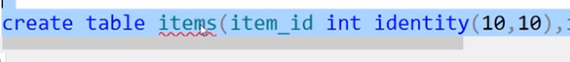



Sequence:

Can be used in any table.(unlike identity)(not associated with a particular table) eg.

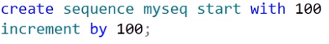

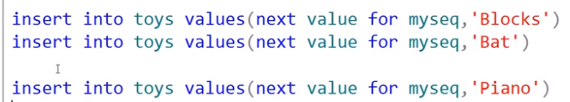

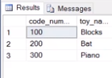

Indexes:

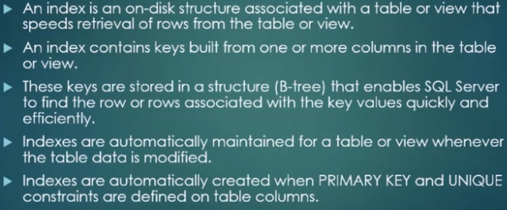

When we use where clause, then the database will traverse all values to check the condition.

To save time and improve the efficiency, we use indexes.

Indexes are created for searching purpose to improve the performance.

Values are stored in ascending or descending order.

Limitations:

Require memory space.

DML statements will become expensive.

When to use:

>We should create indexes when a column is being used in a join condition.

>If query statements are returning more than 5% of the records.

Types:

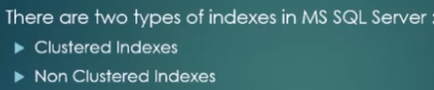

Clustered indexes are a special type whereas unclustered are the general indexes.

There can be no more than one clustered index per table.

New objects are not created for clustered indexes. They are stored in the table itself. They are used in case of primary key constraint.

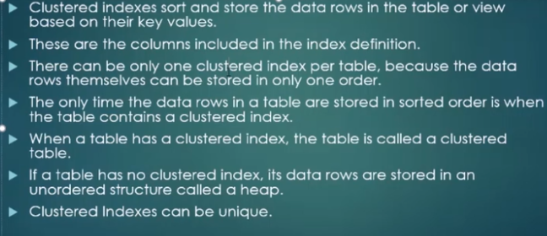

How to create and view an index:

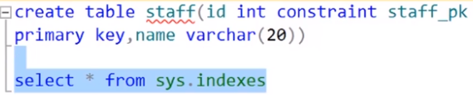

Check names of objects using object id:

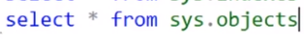

We use join

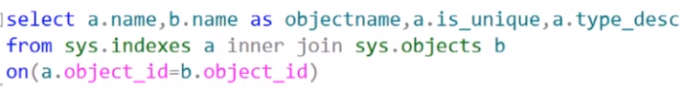

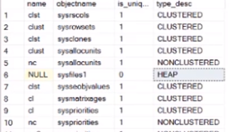



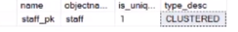

We can see that a clustered index is created for a pk constraint. These indexes can’t be dropped

To create clustered indexes:



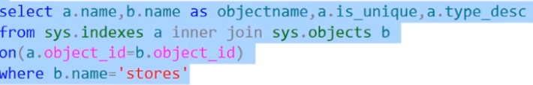

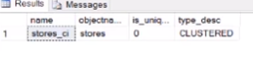

0 means not unique

To create unique ci, we use create unique clustered index

To create nonclustered index:



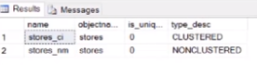

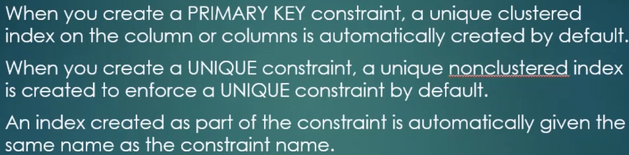

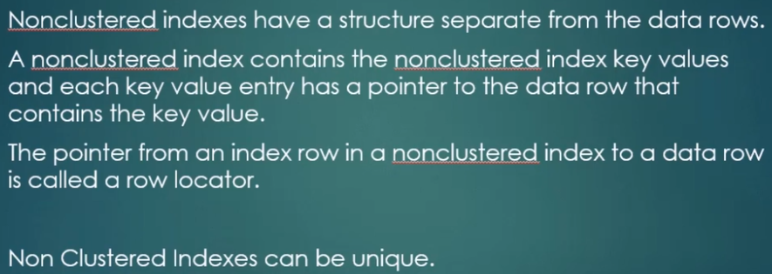

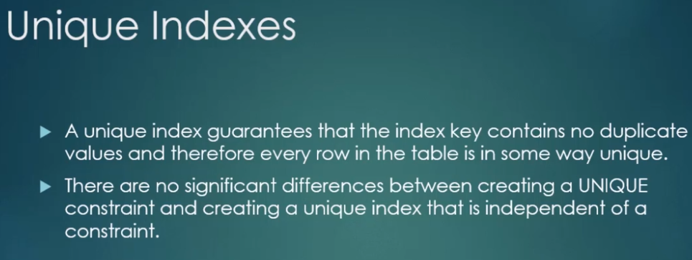

Creating unique index



Filtered index:

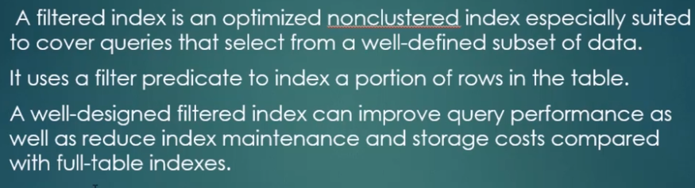

Eg.

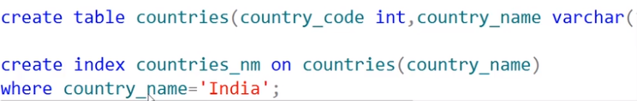

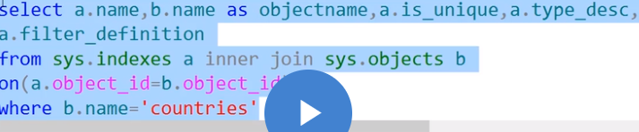

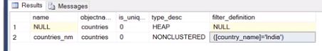

Column store indexes:

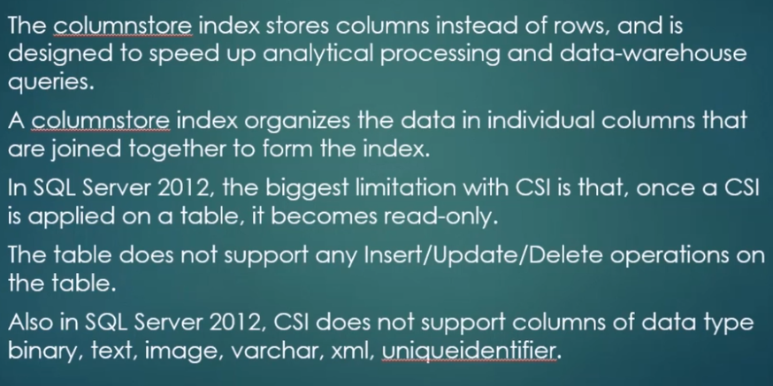

The above mentioned limitations are removed in the following editions.

Eg.:





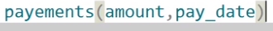

Mostly used in data warehousing due to the limitations.

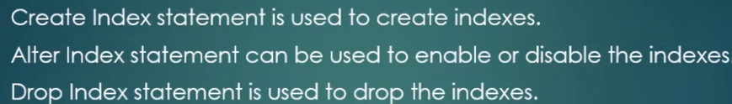

Sys.indexes has a column “is_disabled” which shows if an index is enabled or disabled.



Now, to disable all indexes:



While importing a table, it is advisable to disable the indexes before import and then re-enable the indexes.

Enabling indexes:



Above statement gives error. We use: (may be deprecated)

Views:

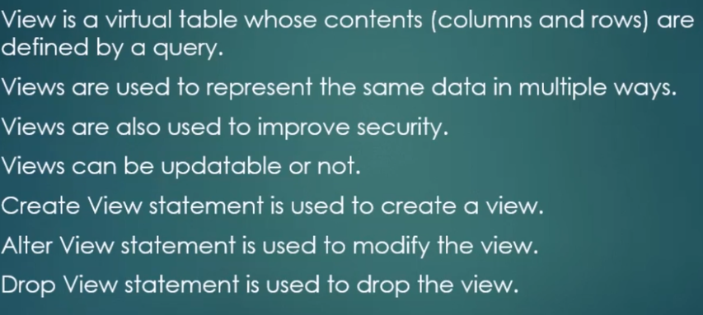

Eg if we have an employee table consisting of 30 columns including personal and job info., then the sales department will need only the job info. So, we create a view and give access of that view. This improves security.





Change column names:

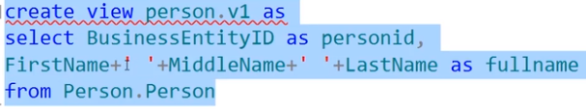

Another way:

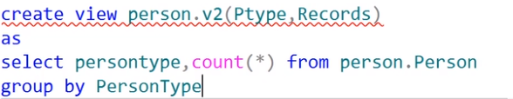

Types of views:

Simple views: Views which are based on one table and do not use joins, group functions or any built in system functions are said to be simple. Updates can be made

Complex views: Views which are based on multiple tables and use joins, group functions or any built in system functions are said to be complex. Updates cannot be made.

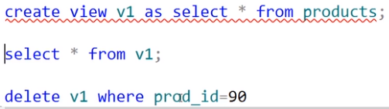

Updates made on a view using dml commands are reflected in the base table.

If we drop a view, then it doesn’t affect the base table.

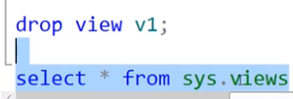To drop a view and view info about a view.

View definition: The subquery which is associated with the view.

Can be viewed using:

Object_definition function

System procedure sp_helptext

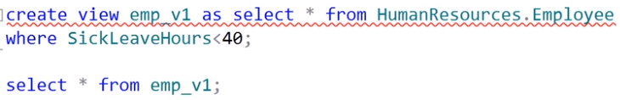



Above query gives the view definition:

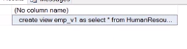

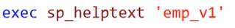  
again, we get the view definition.

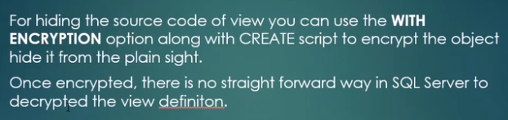

Hiding view definition:

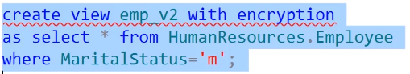

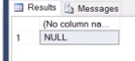once encrypted, cannot be decrypted.

7.1:Stored procedures:

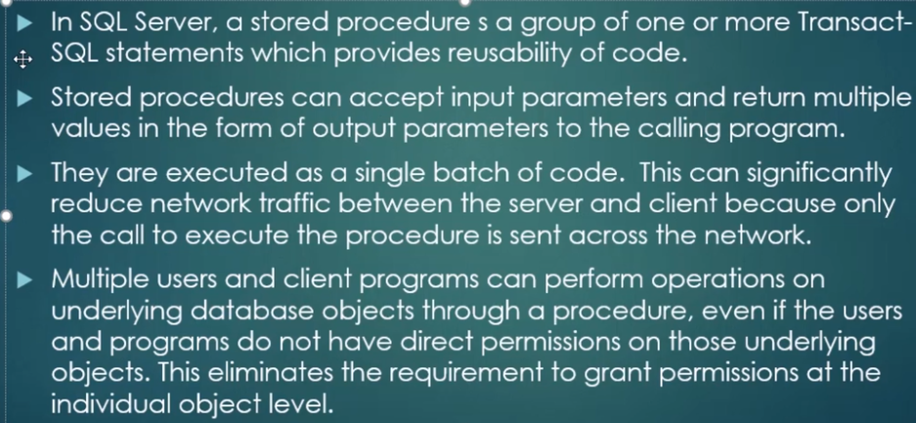

You can pass parameters and return values too

2 types: system & user-defined

System Procedures: Predefined procedures that are created when the database is created.

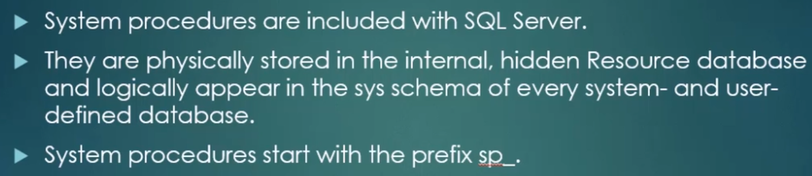

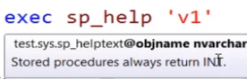To obtain info. about procedures and views.

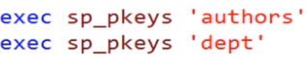Display info. about p. keys

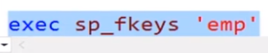 foreign keys

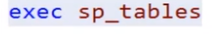info about tables.

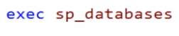info about databases

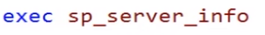info about server

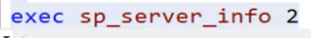info about server attribute 2

User-defined procedure:

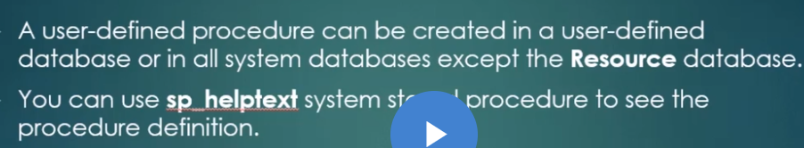

Create procedure:

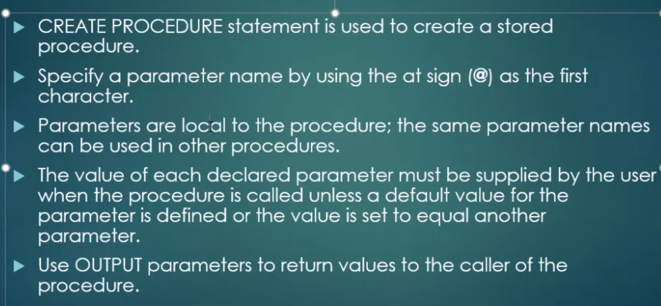



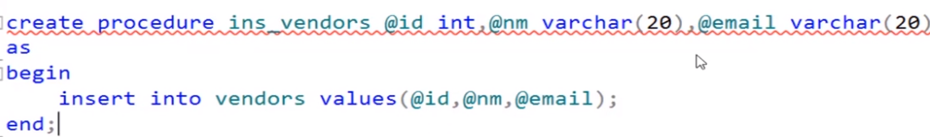



7.2:

Updation procedure:

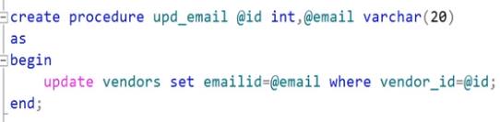

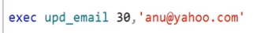 update

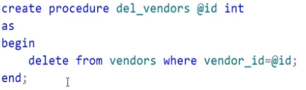delete

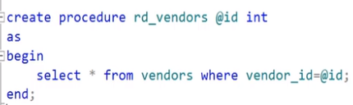select

Procedures can also be used to perform calculations.

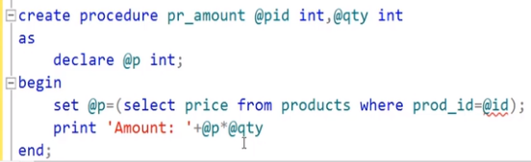

To calculate the amount based on the price and quantity.(above code gives error in the print statement.So, we alter it:)

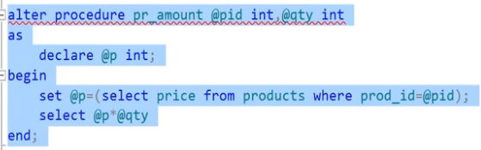

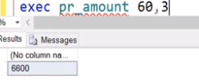

When select statement returns only one column, above method is fine. Else, use below method:

Another method(to return more than one column)

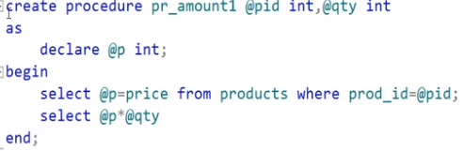

7.3 How to use out-parameters to procedures(till now we were using in- parameters)

To use out parameters, we need to use out keyword or output. They have the ability to return values from the procedure.

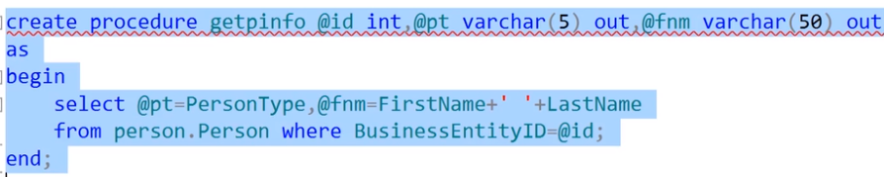

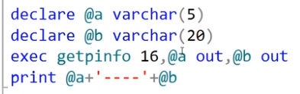 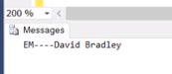

Now, we see return statement, which can return only one value, which is of the integer type(mandatory)

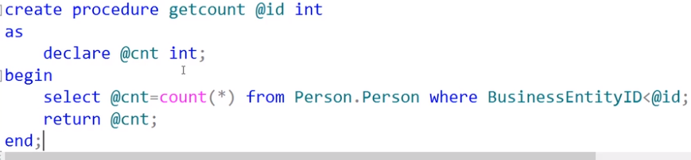

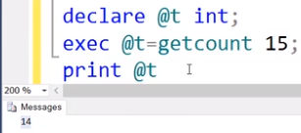 We can recompile a procedure as per the need, manually. SQL does it automatically when we call it the first time or any other time.

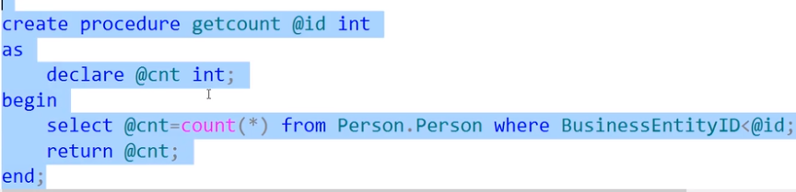

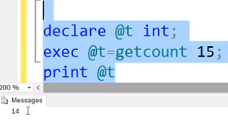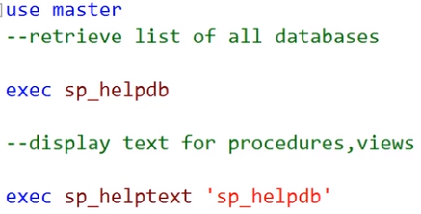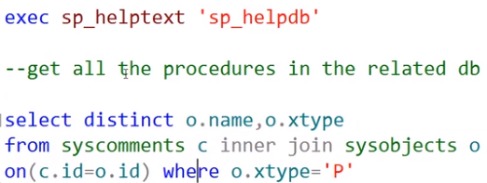

Error Handling:

Try/catch is the structured mechanism for error handling. You can try executing statements in try block and handling errors in the catch block if they occur. This makes it easy to audit or return error-related data, or to take further actions.

When an error generating block of code is written in the try block, then after the error occurs, it will not propagate the error to the database engine. Instead, it will go to the catch block

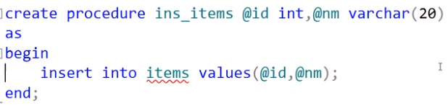

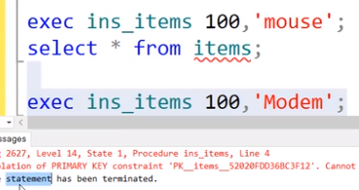

Error is generated because pk constraint is violated.

Now, using try catch:

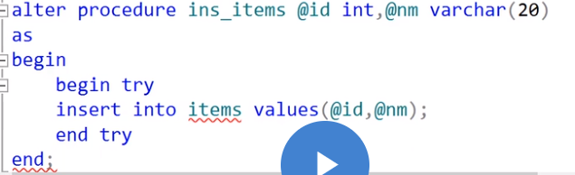

Procedure altered to include try block. Now, we write catch block

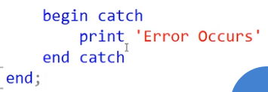

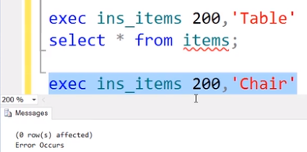

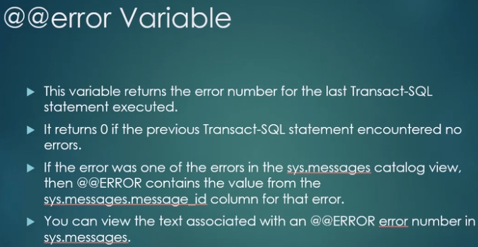

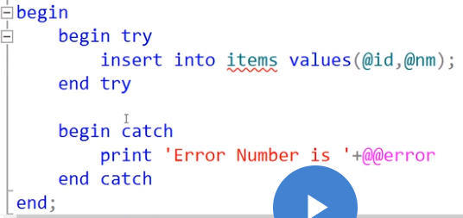

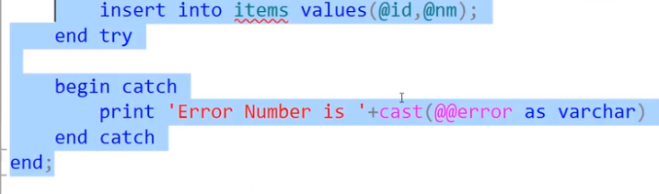

We need to convert @@error to varchar as it is a number.

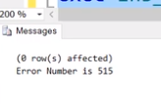

To view the log of messages:

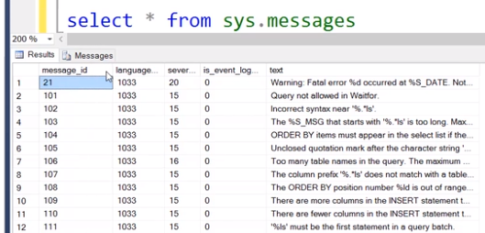

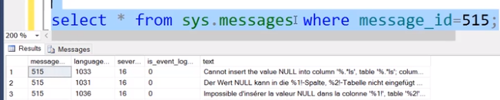

Error functions:

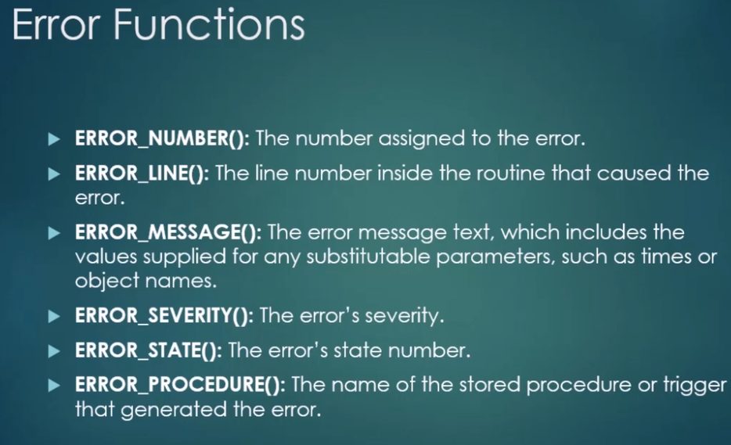

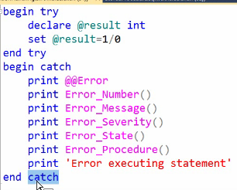

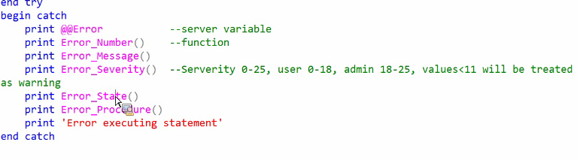

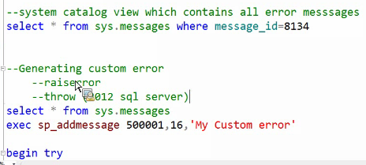

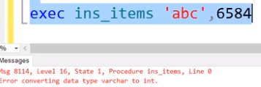

error converting varchar to int(same table as the one used in try catch)

(note that varchar accepts int but int doesn’t accept varchar)



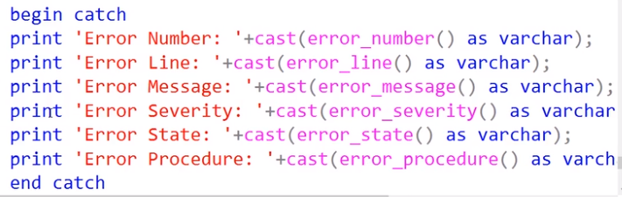

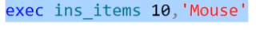

When 10 value is already present in the column which is a pk. Now, error functions are executed:

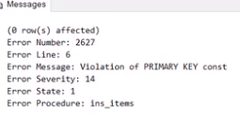

Throws statement:

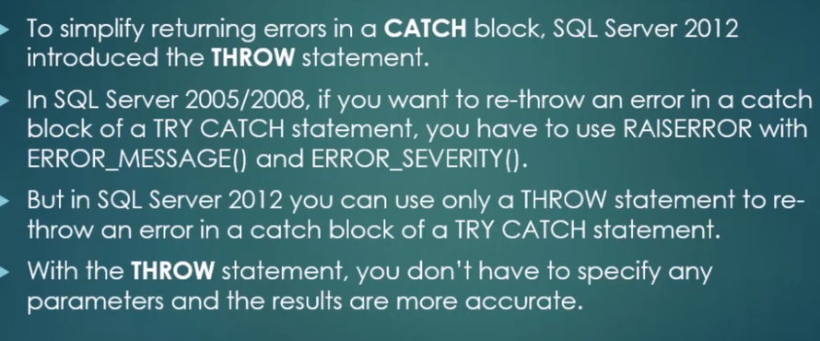

By using throw statement, you can display the error message and the program wont be terminated.

Again using the above example:

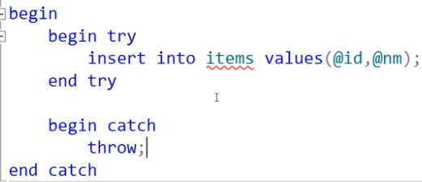

Using throw

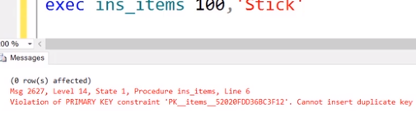

On inserting wrong data, the program is not terminated(0 rows are affected) and error message is displayed.

Before SQL server 2012, we were using raiseerror

Raiserror:

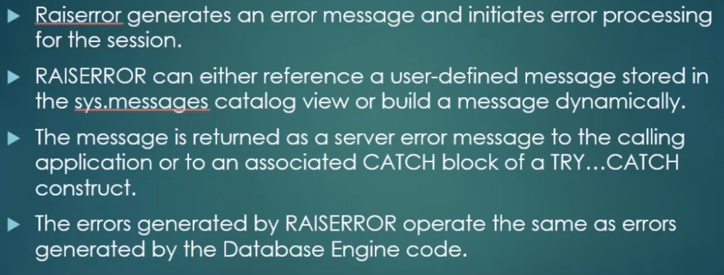

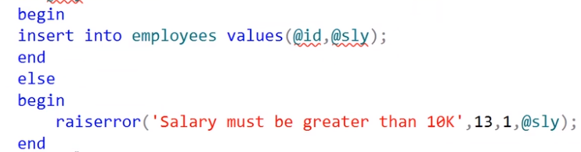

13 is error severity, 1 is error stage, @sly is the value to be returned.

Note: it is spelt as raiserror (only single e)

More about procedures:

Using stored procedures:

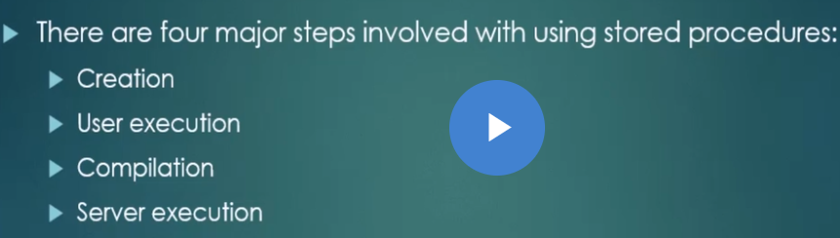

1)Creation:

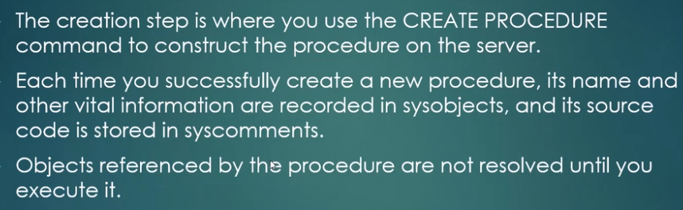

2)User execution:

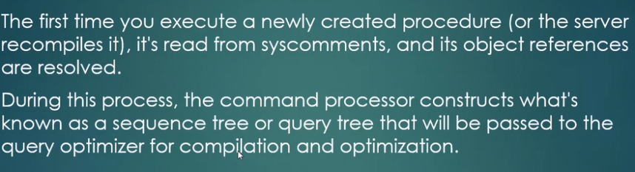

3) Compilation:

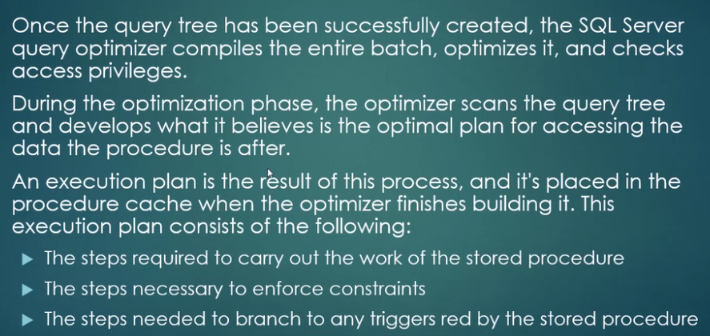

4)Server execution:

